TITTLE:FINANCIAL MANAGEMENT

**ABSTRACT :**

Sees the objective of teaching financial management to be to help managers and potential managers to make sensible investment and financing decisions. Acknowledges that financial theory teaches that investment and financing decisions should be based on cash flow and risk.Financial management refers to the efficient and effective management of money (funds) in such a manner as to accomplish the objectives of the organization. It is the specialized function directly associated with the top management. The significance of this function is not seen in the 'Line' but also in the capacity of 'Staff' in overall of a company. Financial management typically applies to an organization or company's financial strategy, while personal finance or financial life management refers to an individual's management strategy. It includes how to raise the capital and how to allocate capital, i.e. capital budgeting. Not only for long term budgeting, but also how to allocate the short term resources like current liabilities. It also deals with the dividend policies of the share holders. The World of Finance contains chapters on the structure and goals of firm, the role of financial managers, and an examination of the financial environment. Special attention is given to how the Financial Crisis affected nonfinancial companies, financial markets, and financial institutions. Essential Concepts in Finance presents chapters on accounting statements and their interpretation, forecasting, risk and return, the time value of money, and security valuation. Special attention is given to systematic risk and its role in the Financial Crisis.Capital Budgeting and Business Valuation contains chapters on measuring a firm’s cost of capital, capital budgeting decision methods, incremental cash flow estimation, and business valuation. Long-Term Financing Decisions contains chapters on capital structure basics, corporate bonds, preferred stock, leasing, common stock, and dividend policy. The turmoil in the stock and bond markets during the Financial Crisis is examined.Short-Term Financial Management Decisions includes chapters on working capital policy, cash and marketable securities, accounts receivable and inventory, and shortterm financing. Finance in a Global Economy is where international finance topics are covered, in addition to those international topics that are woven throughout the book. The contagion of the Financial Crisis around the world is examined

**INTRODUCTION:**

Let’s define financial management as the first part of the introduction to financial management. For any business, it is important that the finance it procures is invested in a manner that the returns from the investment are higher than the cost of finance. In a nutshell, financial management Endeavors to reduce the cost of financeEnsures sufficient availability of fundsDeals with the planning, organizing, and controlling of financial activities like the procurement and utilization of funds.Financial management is that area of business management devoted to a judicious use of capital and a careful selection of the source of capital in order to enable a spending unit to move in the direction of reaching the goals.Financial management "is the operational activity of a business that is responsible for obtaining and effectivelyutilising the funds necessary for efficient operations". Financial management is concerned with three key activities namely:

•Anticipating financialneeds

•Acquiring financialresources

•Allocating funds inbusiness

Traditional approach to financial management Traditionally, financial management was considered as a branch of knowledge with focus on the procurement of funds. Instruments of financing, formation, merger and restructuring of firms, legal and institutional frame work involved therein occupied the prime place in this approach. Modern approach to financial managementModern phase has shown the commendable development with combination of ideas from economic and statistics that led the financial management more analytical and quantitative. The key work area of this approach is rational matching of funds to their uses, which leads to the maximisation of shareholders' wealth.

**OBJECTIVES:**

Plan to utilize fund in such a way to

maximize wealth of the organization.

Directing of fund in such a manner to

generate revenues timely with low cost as

per decided goal of the organization.

**LITERATURE SURVEY:**

FINANCIAL MANAGEMENT REFORM LITERATURE REVIEW

BY Carole pretorius,nico pretouris

January 2009

Preface

This review of literature on experience with Public Financial Management Reform was commissioned by DFID on behalf of the Dutch Ministry of Foreign Affairs, the Swedish International Development Cooperation Agency (Sida), the Canadian International Development Agency (CIDA) and the African Development Bank (AfDB). It was envisaged as the preliminary stage of a joint evaluation, and was overseen by a Steering Group of experts from the contributing agencies. Strong Public Financial Management (PFM) systems are essential to improved service delivery, poverty reduction and to achievement of the MDGs. Effective PFM systems maximise financial efficiency, improve transparency and accountability, and – in theory – will contribute to long-term economic success.

**ADVANTAGES OF FINANCIAL MANAGEMENT:**

●organisaton management facilitates beter decision making by providing all fnancial informaton regarding

●available to all business users. It is called transparency of informatIn fnancial management concept, all informaton’s collected are ron that helps to develop beter ecorded systematcally and made it understanding.

●and should not go above the pre-set standards. This facilitates fnaThe fnance manager ensure that all actvites of business are in accornce controldance with the estmated costs

●wastage management ensures that all fnancial resources are efciently utlised and there is no

●Financial management aims at raising the proft of the concern and wealth of the shareholders.

**DISADVANTAGES OF FINANCIAL MANAGEMENT:**

●These tools are costly to use and are tme consuming controlling and measuring the cost, fnancial management implies various fnancial control tools.

●Financial management leads to rigidity by setng certain standards for measure performance.

●very difcult task. Financial management requires determinaton of standards for measuring actual performance which is

●startng of process but,its implementaton become difcult during operThe fnancial control measures put forward by fnancial management caton of the process be easily applied at the

●such deviatons are found out,it is ineffectve management can work toward managing or avoiding deviatons only if the real reasons

●standards are no proper criteria for setng up standards and there may be chances to set improper

**METHODOLOGY:**

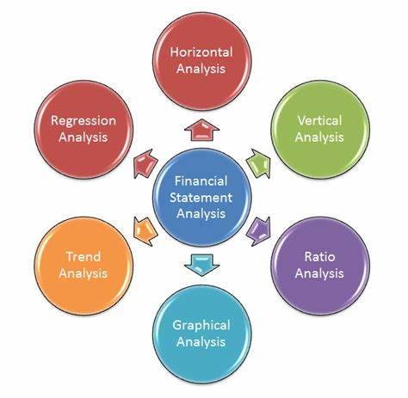

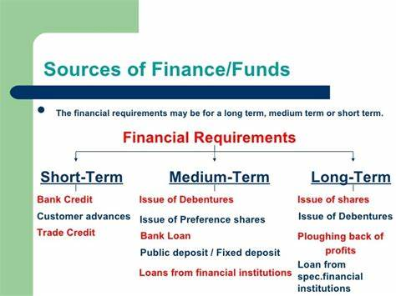

DATAANALYSIS:

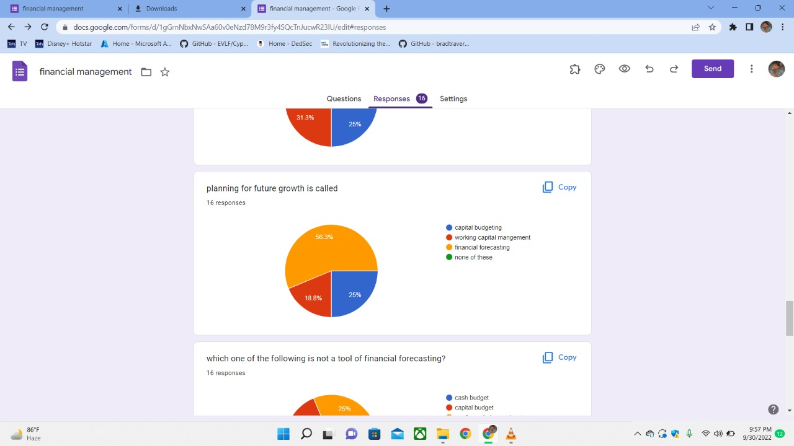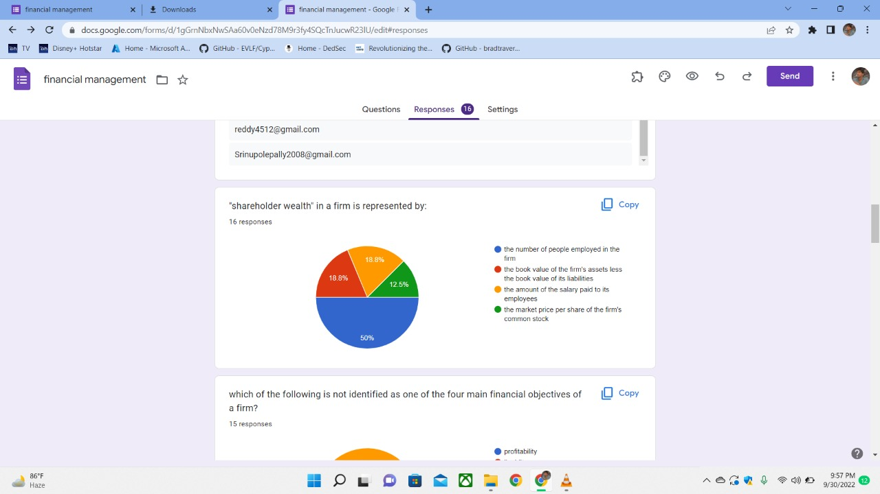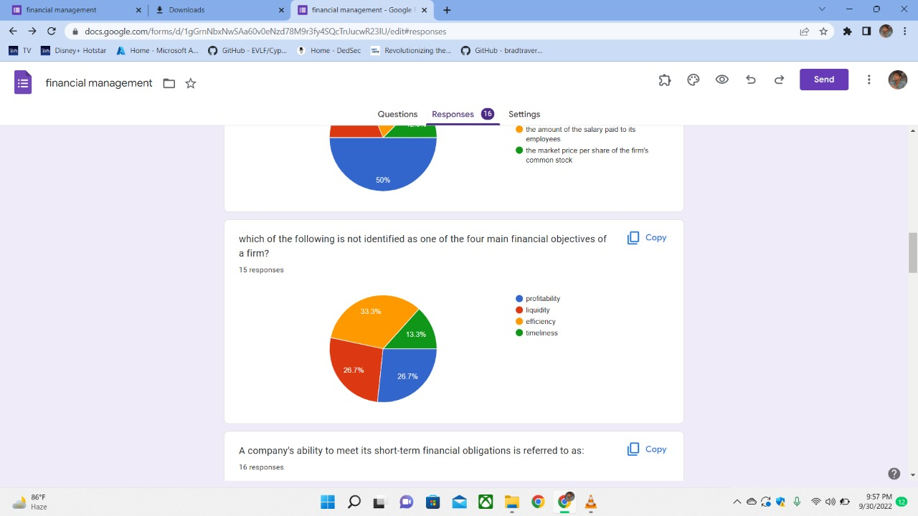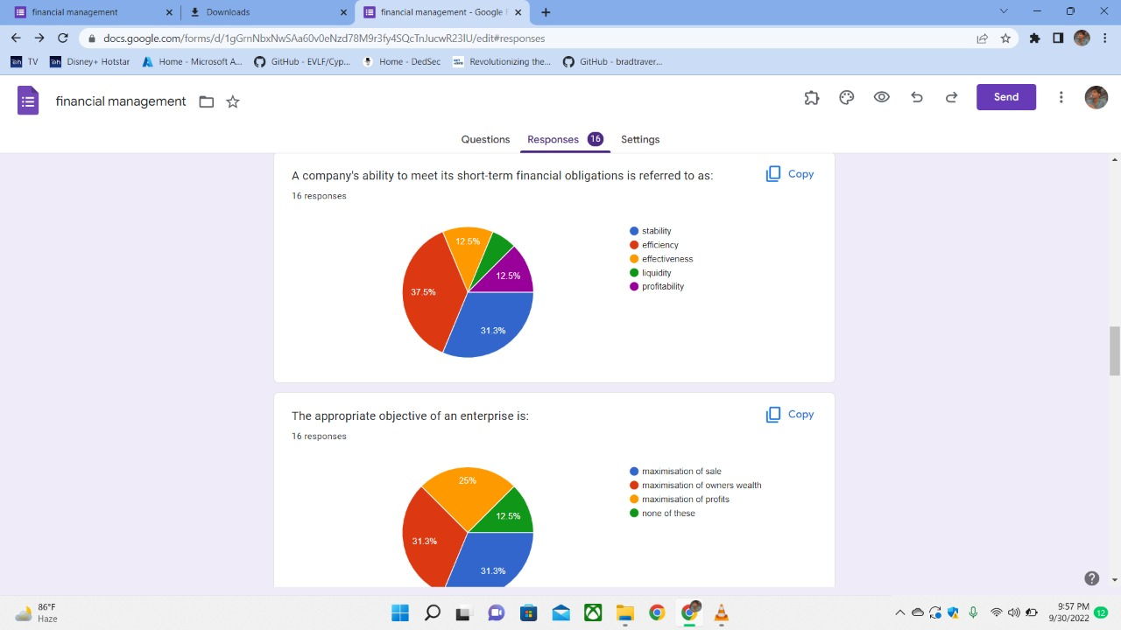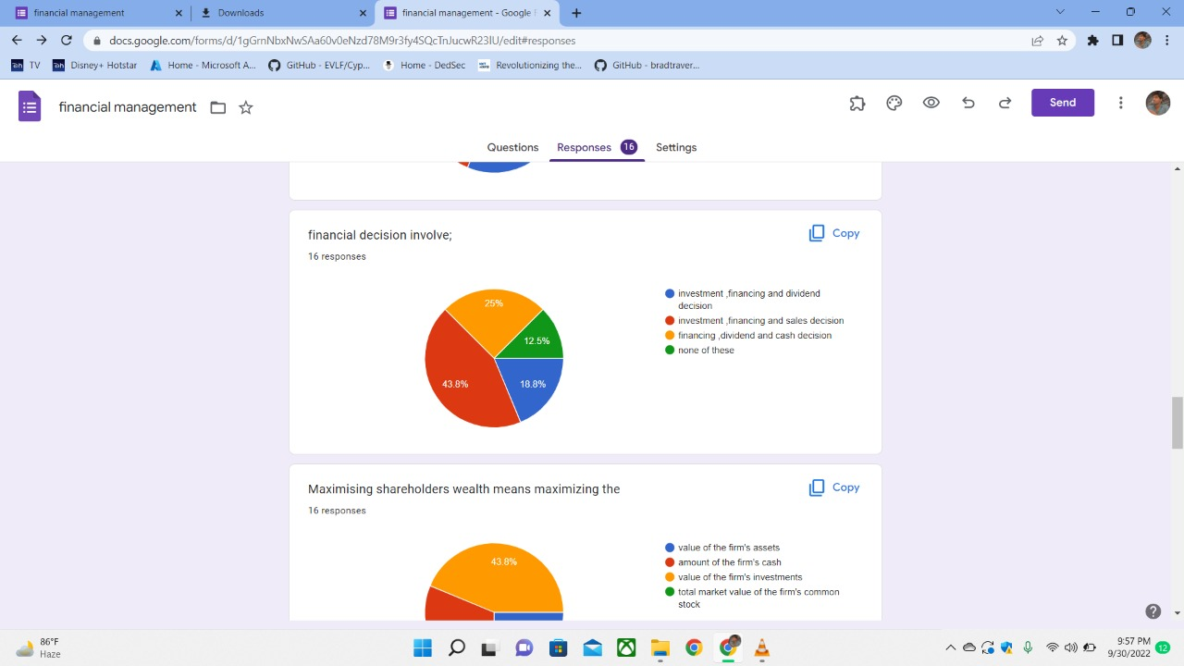

**CONCLUSION:**

Rising of fund and utilization of fund is very important aspect of

organization. Every organization should have planned to utilize fund in efficient manner.“Management accountants focus on forecasting. They have an exciting and forward-looking strategic role in many different types of organizations. They use various tools, such as ratio analysis and investment appraisal, to identify measure and analyze the financial performance of a company.Many CIMA-trained management accountants are at the heart of top businesses in a wide variety of roles, including financial analyst or finance director. They contribute to decisionmaking across the organisation. The analysis they provide is vital in taking a business forward.

**REFERENCES:**

Brealey, Richard A., and Stewart C. Myers. *Principles of Corporate Finance*. 4th ed. McGraw-Hill, 1991.

Brigham, Eugene F. *Fundamentals of Financial Management.*5th ed. Dryden Press, 1989.

Gallinger, George W., and Jerry B. Poe. *Essentials of Finance: An Integrated Approach*. Prentice Hall, 1995.

Higgins, Robert C. *Analysis for Financial Management.*McGraw-Hill, 2000.

Noe, Thomas H. "Corporate Finance, Incentives, and Strategy." *Financial Review.*November 2000.

Petty, J. William, Arthur J. Keown, David F. Scott, Jr., and John D. Martin. *Basic Financial Management*. 6th ed. Prentice Hall, 1993.

Spiro, Herbert T. *Finance for the Nonfinancial Manager*. 3rd ed. Wiley, 1988.